- Resolve Merge Conflicts
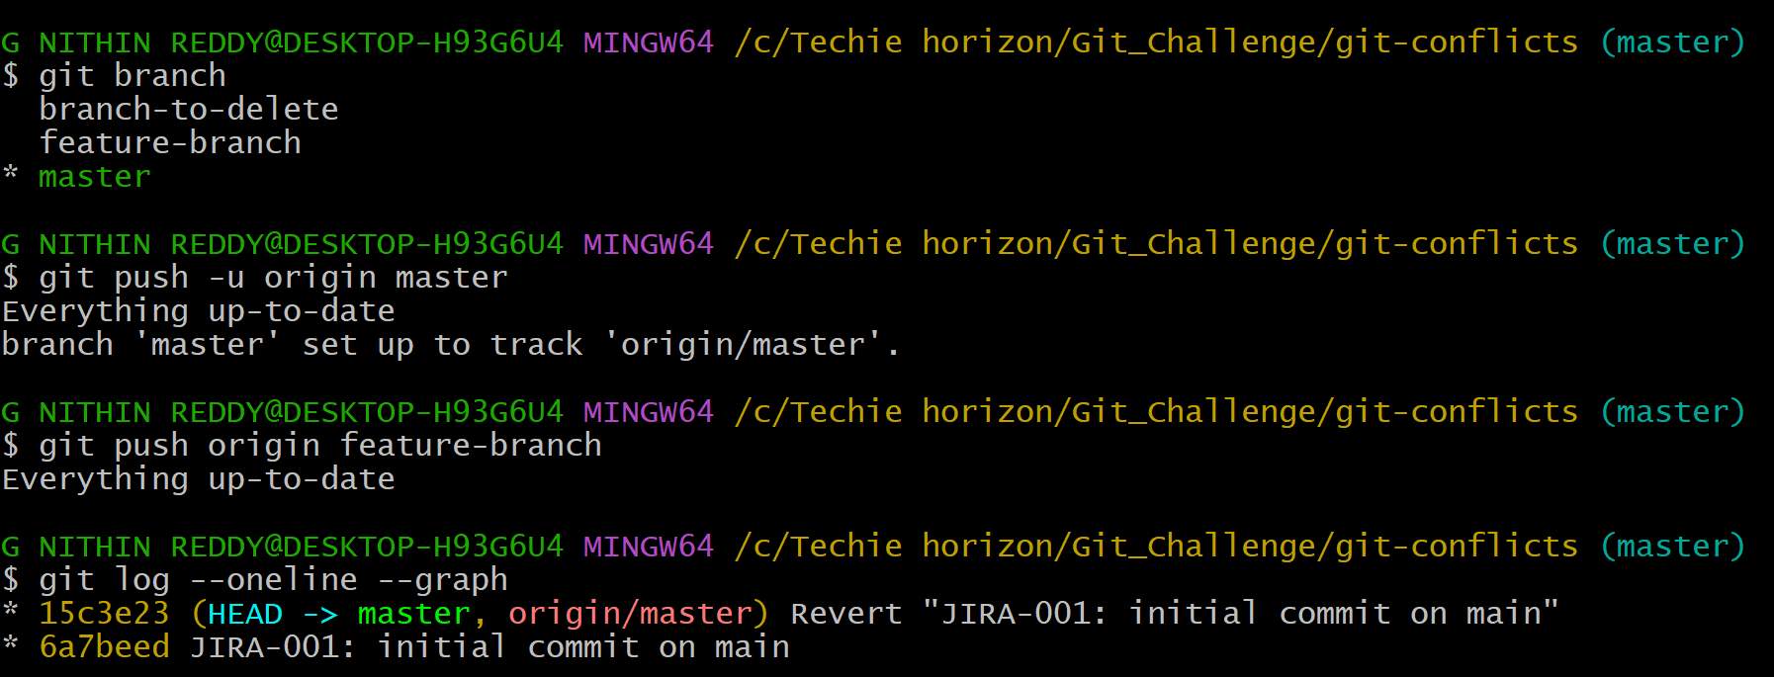
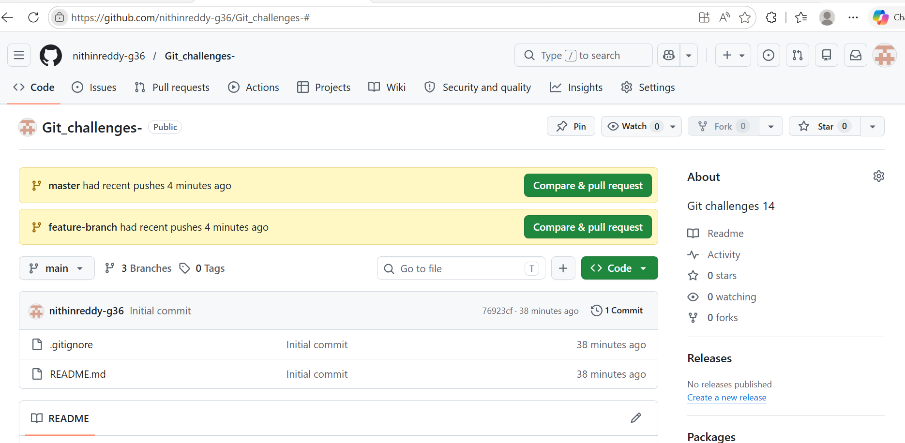
* In real teams, two developers often edit the same line of code simultaneously. Git can't decide which change to keep — so it creates a merge conflict. You must manually resolve it. This is one of the most common daily Git tasks.
Objective: Create an intentional merge conflict between two branches editing the same line, resolve it manually, and push the result.

Steps:

- Created a repo and made initial commit on master
- Created feature-branch, edited same line in conflict.txt as User B
- Switched to master, edited same line as User A
- Ran git merge feature-branch — conflict markers appeared
- Manually removed markers, kept merged content
- Ran git add conflict.txt then git commit
- Pushed both branches to GitHub
Outcome: Merge conflict was intentionally created, manually resolved, and pushed. git log --oneline --graph confirmed the merge commit with all branches visible.
- Recover Deleted Branch
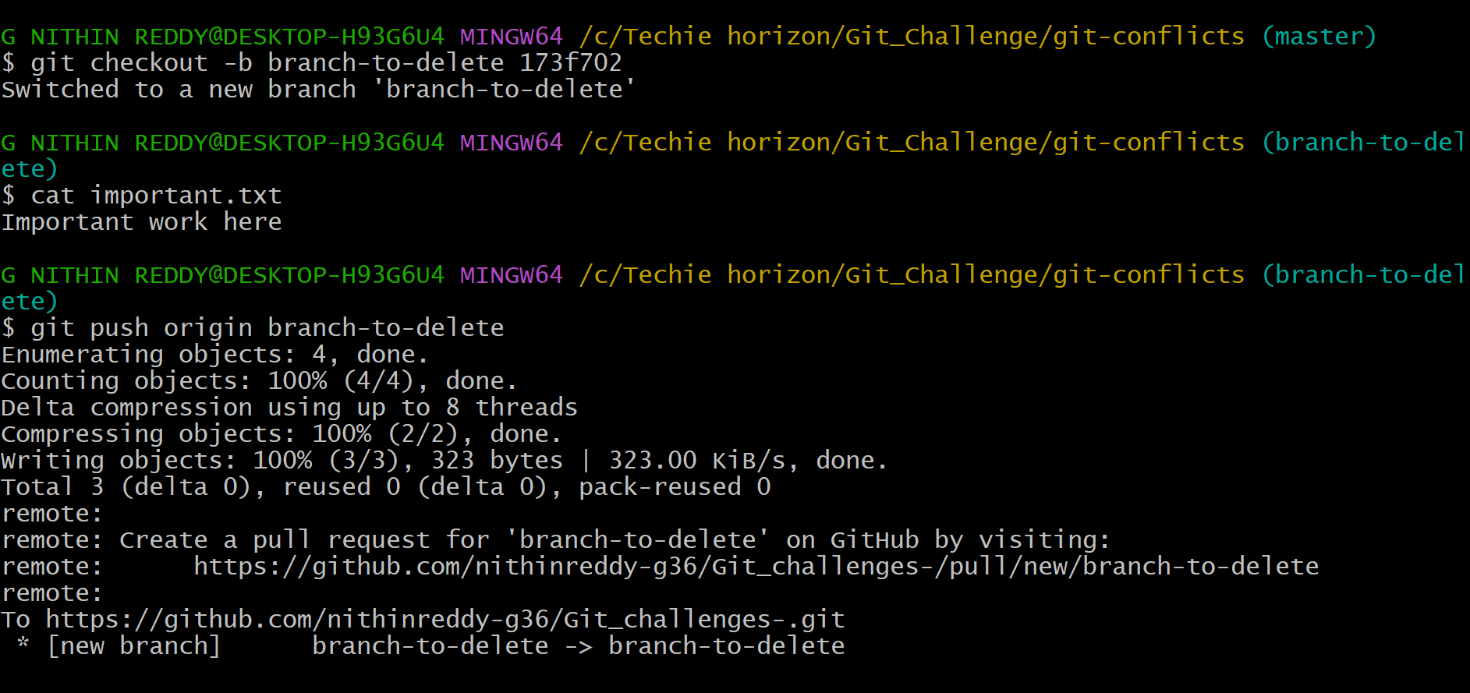
Objective: Delete a local branch and recover it using git reflog.
Steps:
Created branch-to-delete with a commit containing important.txt
Switched to master and deleted it with git branch -D branch-to-delete
Ran git reflog and found the deleted branch's last commit SHA
Ran git checkout -b branch-to-delete <SHA> to restore it
Verified important.txt was back and pushed to GitHub
Outcome: Deleted branch was fully recovered. File and commit history were restored exactly as before deletion.
- Undo Wrong Push
Objective: Push a wrong commit to GitHub and undo it without losing history using git revert.
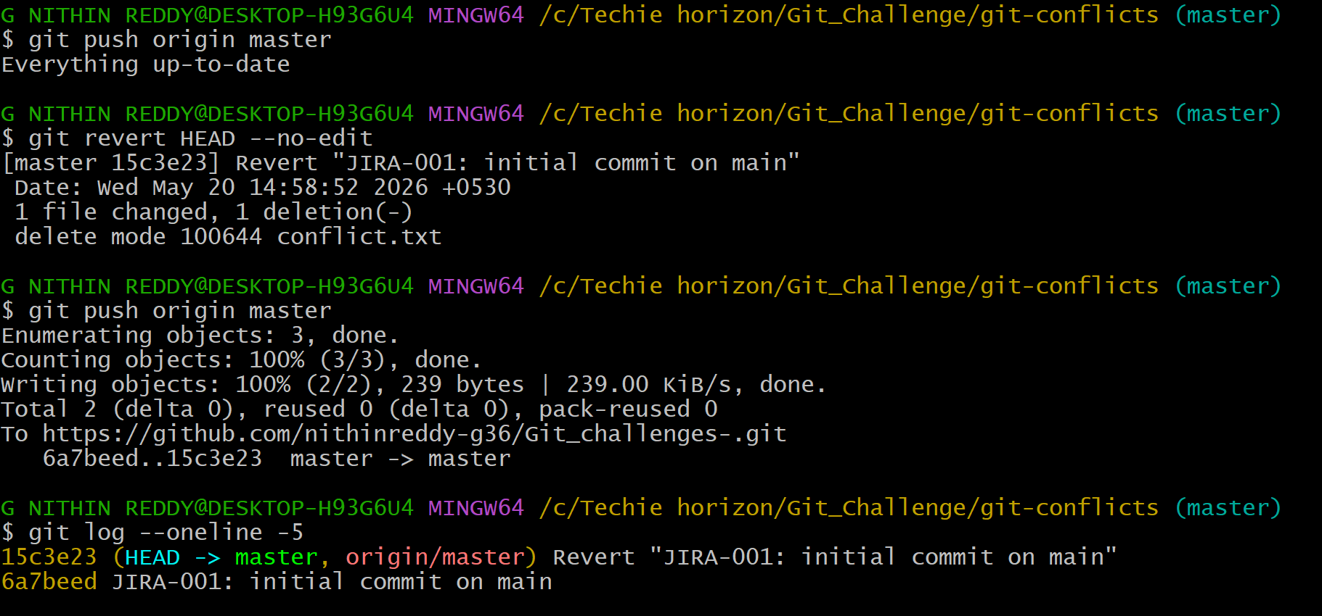
* I pushed a wrong commit to GitHub. git revert creates a new commit that undoes the change — history is preserved, safe for shared branches.
Outcome: Wrong commit was undone safely. Git log showed the original wrong commit and the revert commit above it — full history preserved.
- Amend a Commit
Objective: Make a commit then add a missing file to it using git commit --amend.
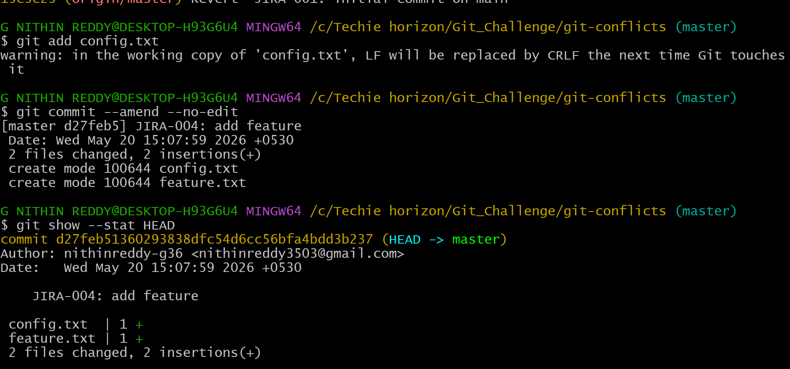
* Committed feature.txt but intentionally left out config.txt. Then staged the missing file with git add config.txt and ran git commit --amend --no-edit to rewrite the last commit to include it. Used git show --stat HEAD to confirm both files appeared in one single commit. Pushed with --force because amend changes the commit SHA.
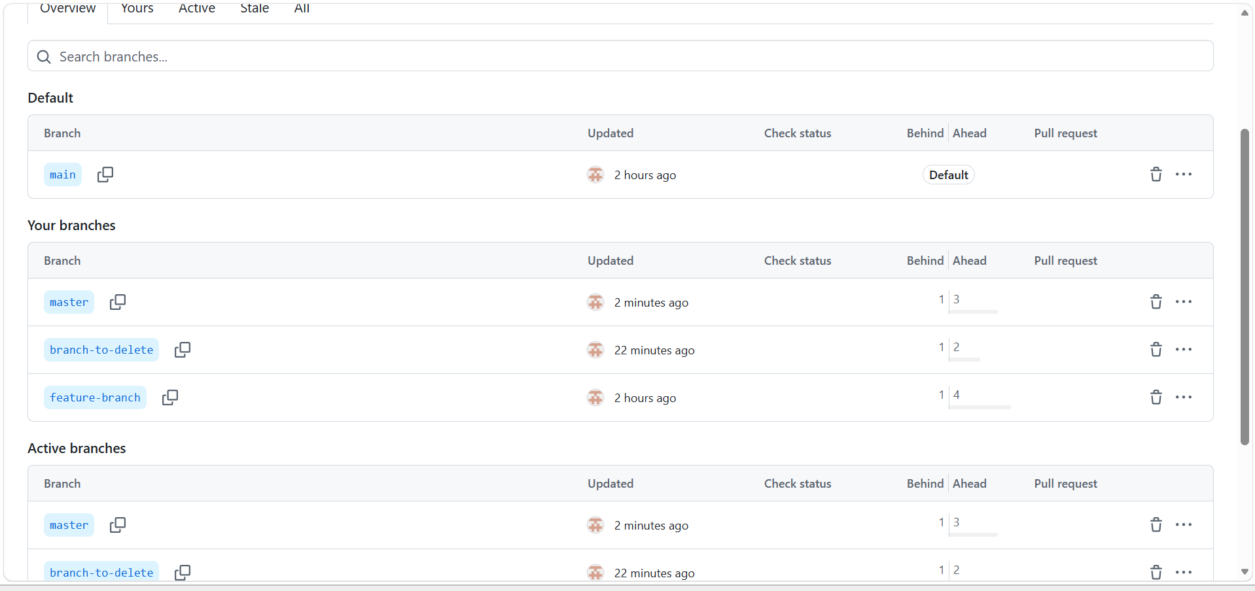
Outcome: Both files appeared in one single amended commit. No extra commit was created in the log.
- Cherry-pick a Commit
Objective: Squash multiple WIP commits into one single clean commit.
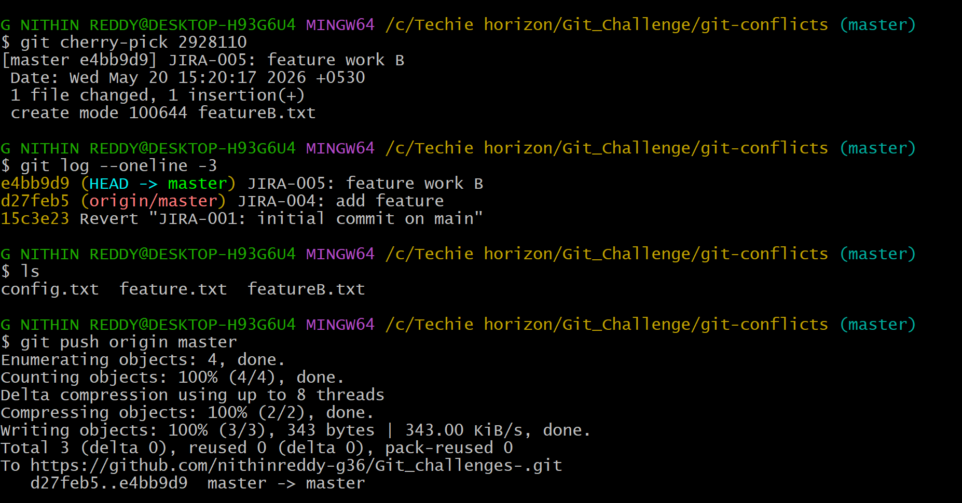
*Created branch cherry-source with 3 commits — feature A, a hotfix, and feature B. Used git log --oneline to note the hotfix commit SHA. Switched to master and ran git cherry-pick <SHA> to apply only the hotfix onto master. Verified that only hotfix.txt appeared on master, not the other two feature files.
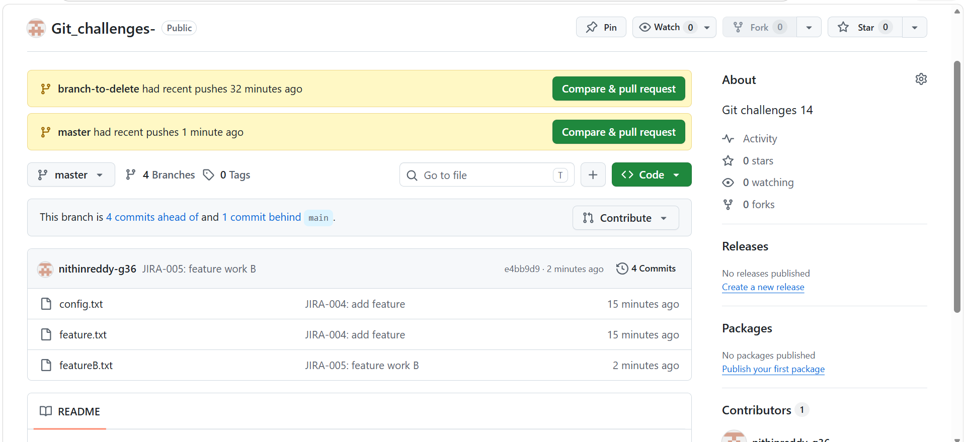
Outcome: Four messy WIP commits were squashed into one clean commit. Git log showed only one entry where there were four before.
- Interactive Rebase
Objective: Squash multiple WIP commits into one single clean commit.
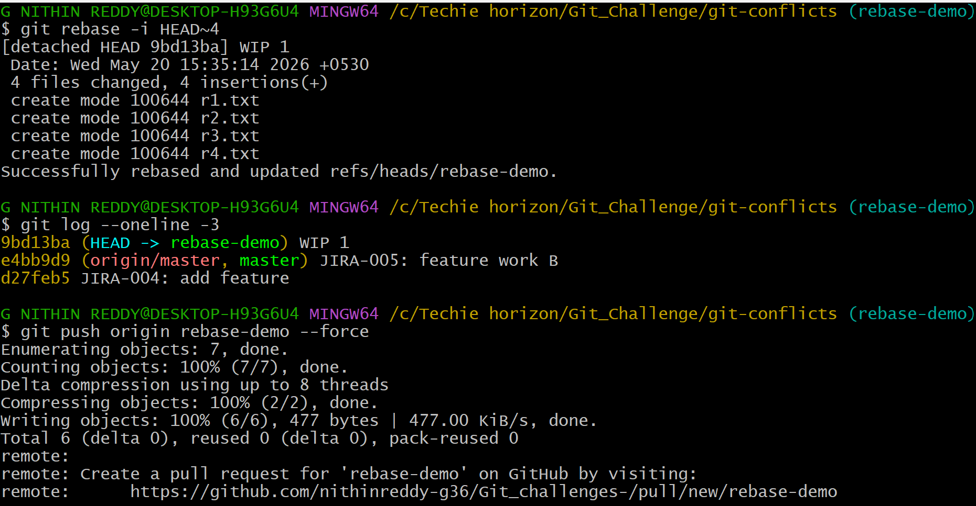
*Created branch rebase-demo and made 4 WIP commits with messages "WIP 1" through "WIP 4". Ran git rebase -i HEAD~4 which opened an editor. Changed lines 2, 3, 4 from pick to squash. Saved — a second editor opened for the combined message. Wrote "JIRA-006: complete feature implementation". Git log then showed only 1 clean commit where there were 4 before.
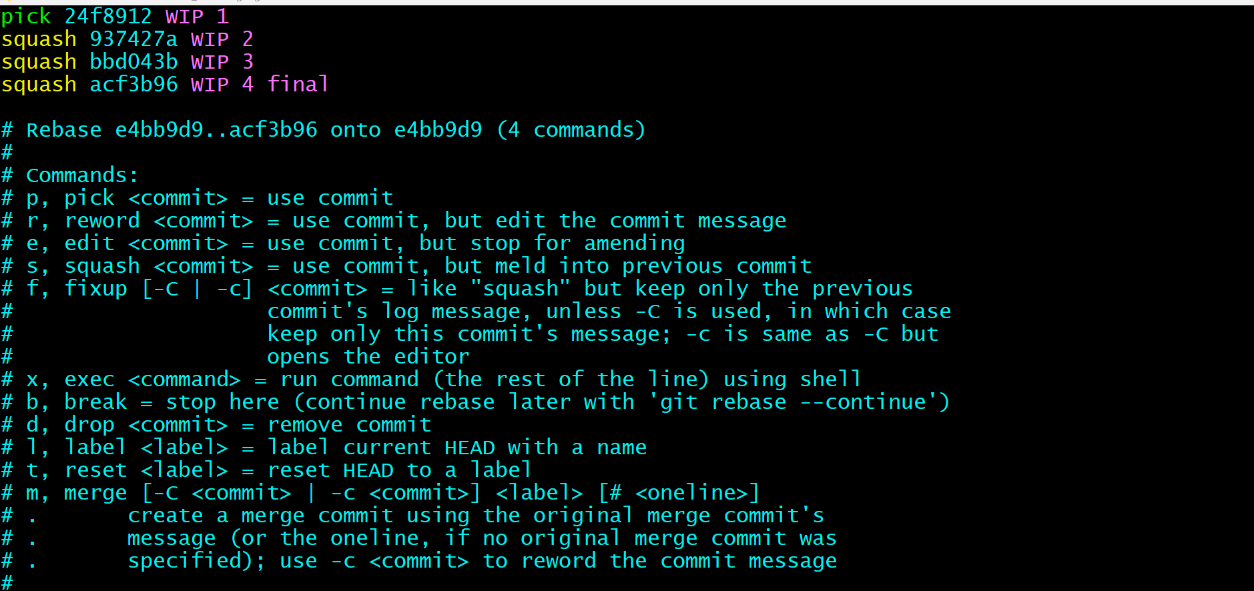
Outcome: Four messy WIP commits were squashed into one clean commit. Git log showed only one entry where there were four before.
- Tagging & Release
Objective: Create tag v1.0, push to GitHub, delete it, then restore it.
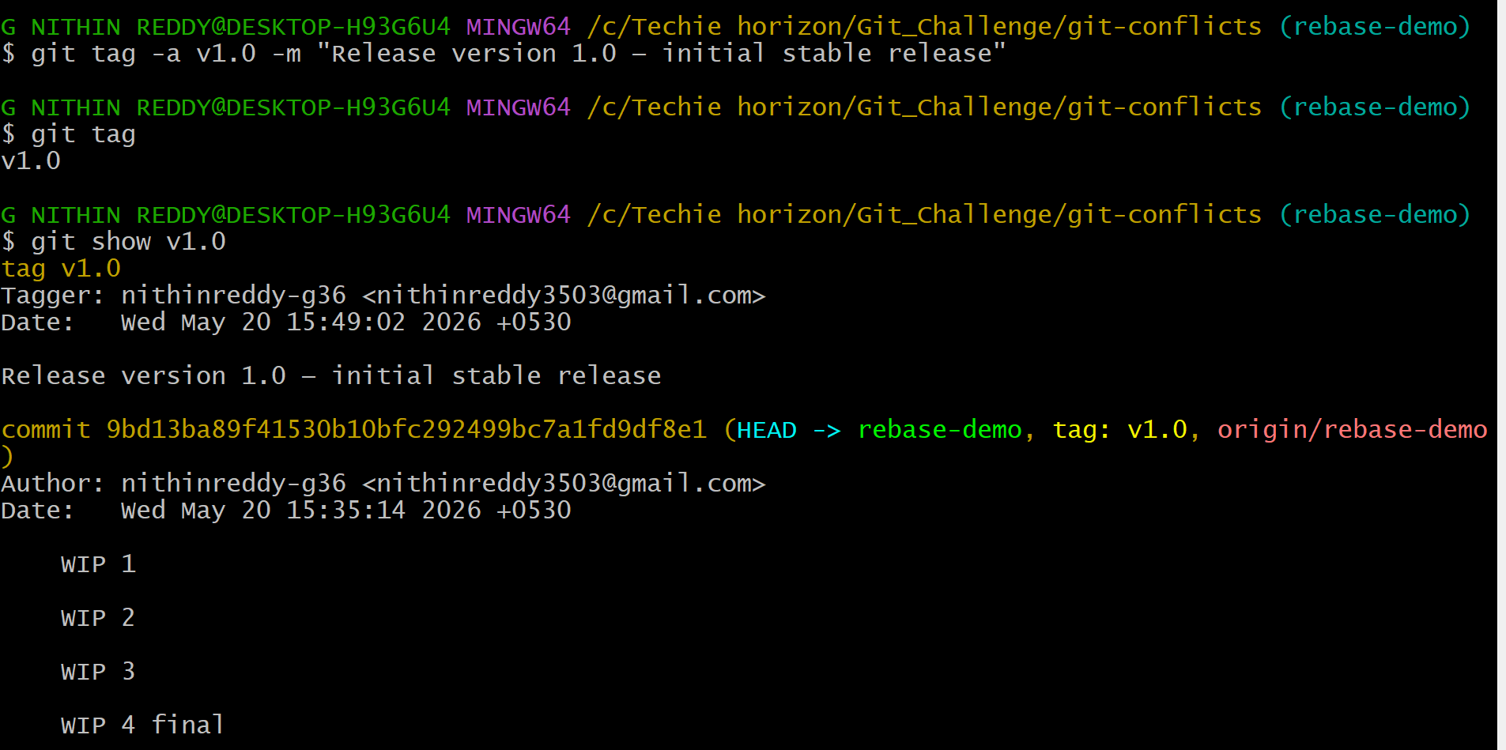
Created an annotated tag with git tag -a v1.0 -m "Release version 1.0" and pushed it with git push origin v1.0. Confirmed it on GitHub. Then deleted it locally with git tag -d v1.0 and remotely with git push origin --delete v1.0. Found the original commit SHA from git log and recreated the tag on that exact SHA, then pushed it back.
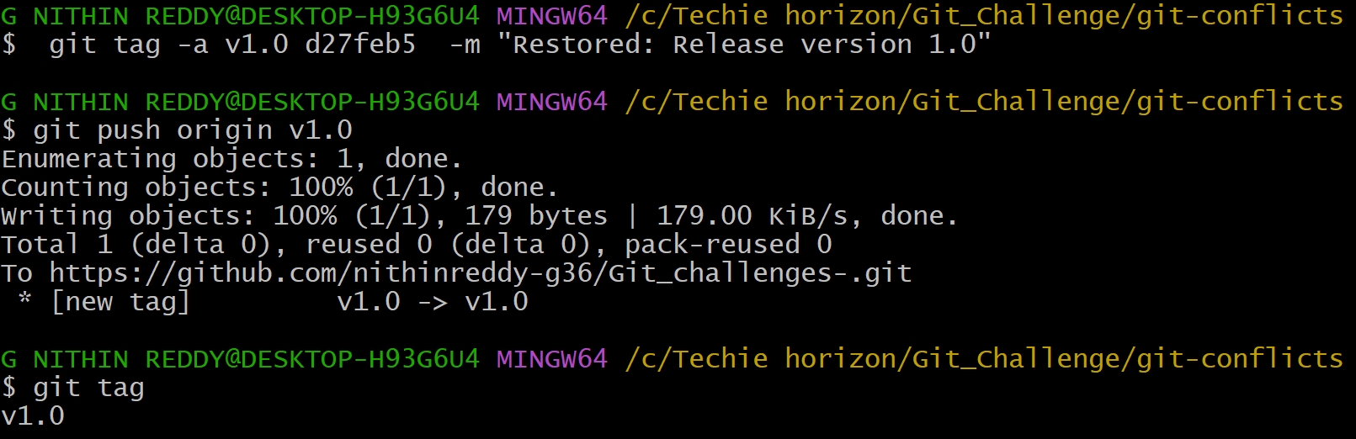
Outcome: Tag v1.0 was created, pushed, deleted from both local and remote, and fully restored. GitHub Tags page confirmed the tag after each push.
- Clone with Sparse Checkout
Objective: Clone only a specific subdirectory of a repo instead of the whole repo.
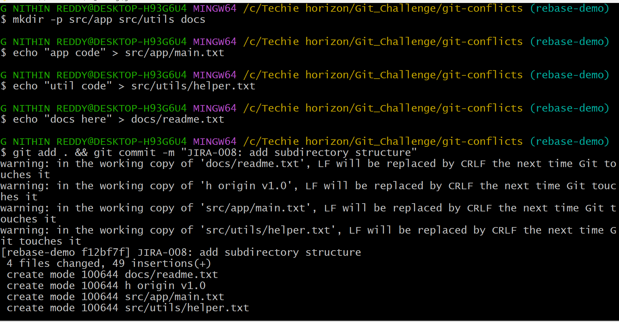
*Added folders src/app, src/utils, and docs to the repo and pushed. Then in a new empty folder, cloned with git clone --no-checkout to skip downloading files. Enabled sparse checkout with git sparse-checkout init --cone. Set the target with git sparse-checkout set src/app. After git checkout master, only the src/app folder downloaded — docs and src/utils were not present.
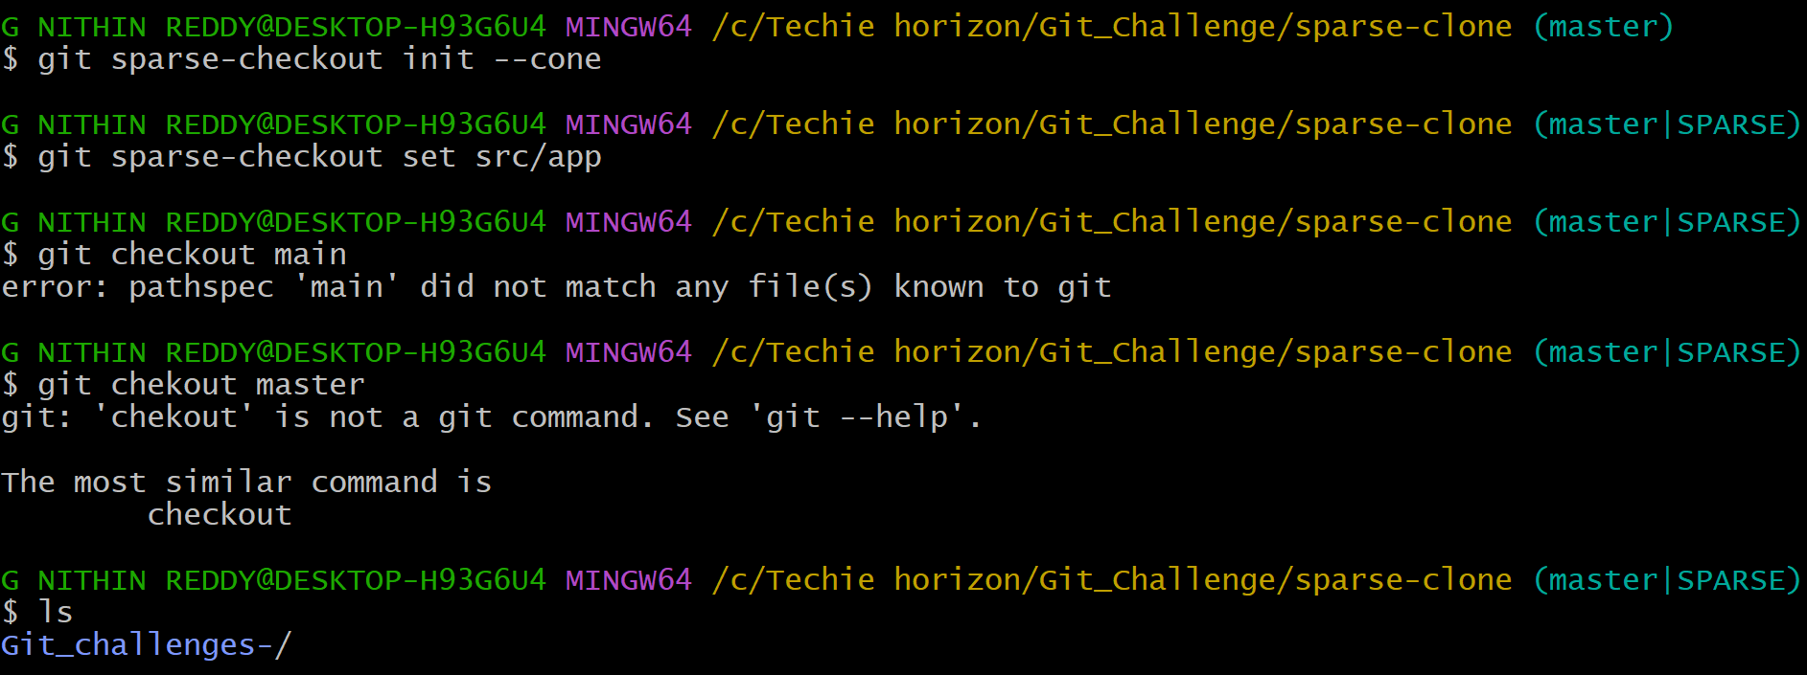
Outcome: reset --hard left only 1 commit (destructive). revert left 3 commits with full history intact (non-destructive). Difference clearly demonstrated.
- Reset vs Revert Challenge
Objective: Demonstrate the difference between git reset --hard and git revert.
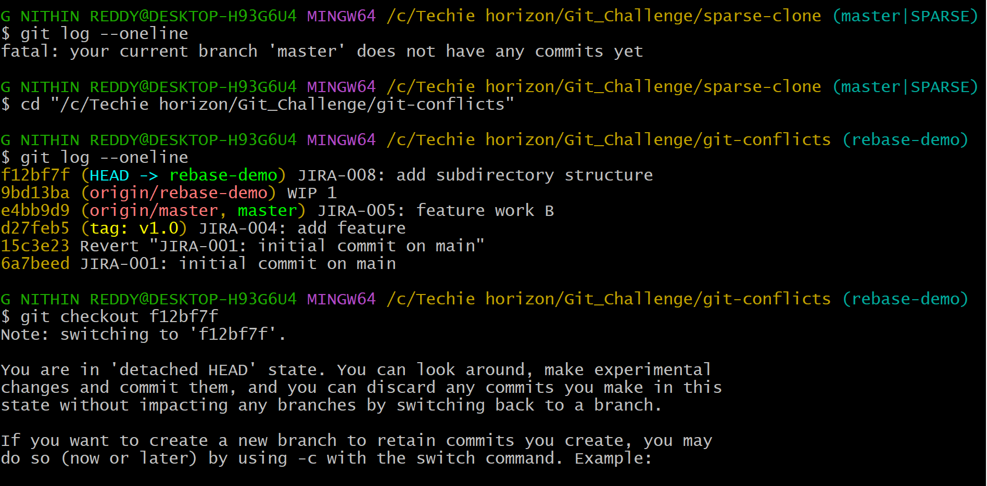
*Ran git checkout <past-commit-SHA> — Git warned "You are in detached HEAD state". Confirmed with git status. Created experiment.txt and committed in this state. Then ran git checkout -b detached-head-branch to save the work as a real branch before it could be lost. Pushed the branch to GitHub.
- Detached HEAD Challenge
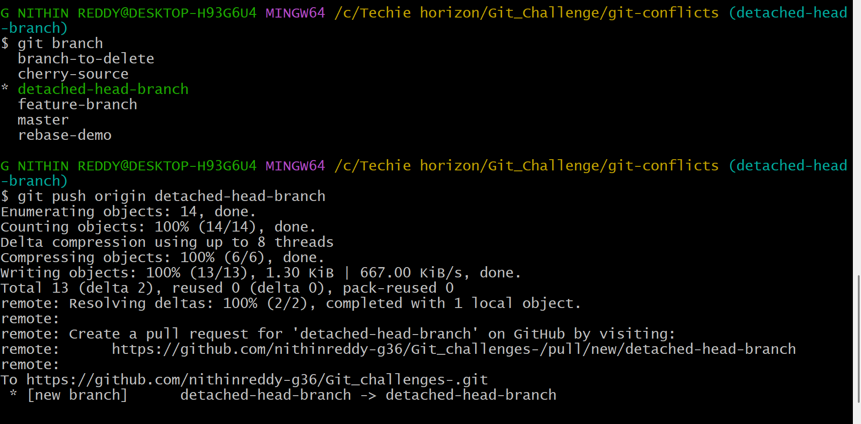
Outcome: reset --hard left only 1 commit (destructive). revert left 3 commits with full history intact (non-destructive). Difference clearly demonstrated.
- Git Hooks Challenge
Objective: Configure a pre-commit hook to reject commits not starting with JIRA
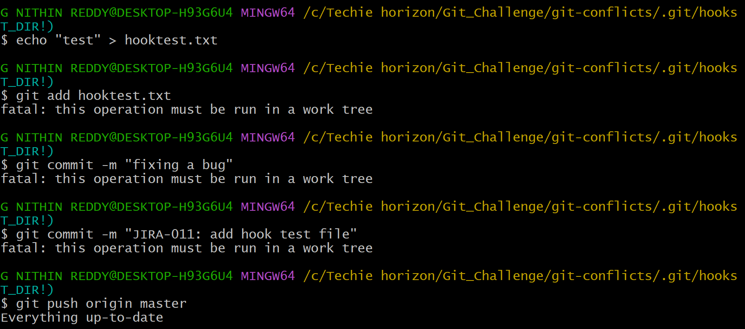
*Navigated to .git/hooks and created a file named pre-commit with a bash script that checks if the commit message starts with JIRA- followed by numbers. Made it executable with chmod +x pre-commit. Tested with a bad message ("fixing a bug") — hook printed the error and blocked the commit. Tested with "JIRA-011: add hook test file" — commit went through normally.
Outcome: Hook rejected commits without JIRA prefix and allowed correctly formatted ones. Commit message standards enforced automatically.
12. Squash Merge vs Rebase Merge
Objective: Show the difference between squash merge and rebase merge with evidence.
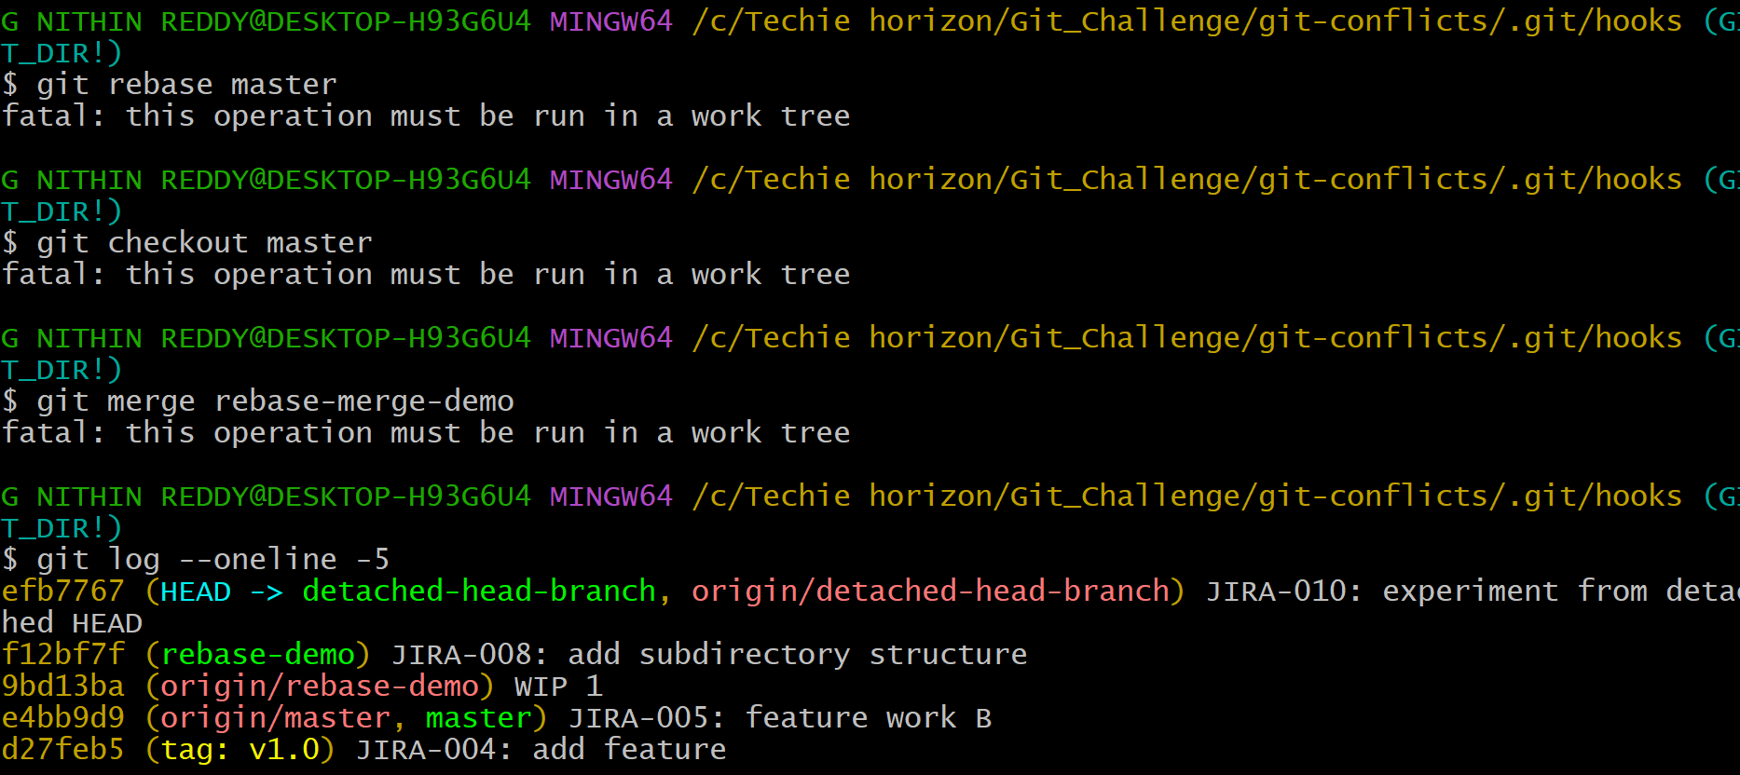
*Created branch squash-demo with 3 commits. Switched to master, ran git merge --squash squash-demo and committed — git log showed 1 new commit on master. Then created rebase-merge-demo with 3 commits. Ran git rebase master on it, switched to master, ran git merge rebase-merge-demo — git log showed all 3 individual commits added linearly.
Outcome: Squash merge produced 1 combined commit. Rebase merge produced 3 individual linear commits. Both strategies clearly demonstrated in git log output.
13. Fork & Pull Request Workflow
Objective: Fork a repo, make a change, and submit a pull request to the original
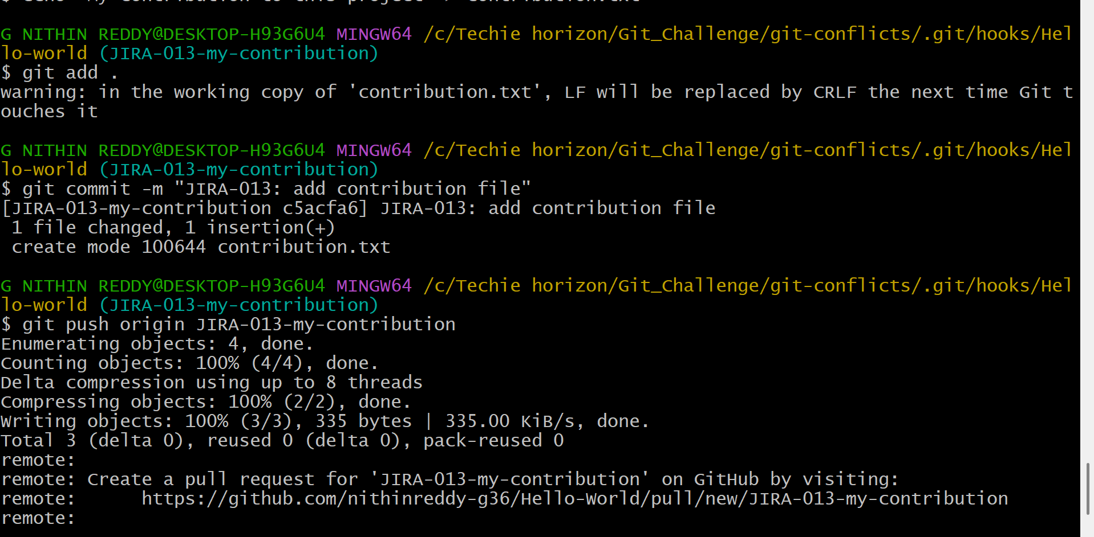
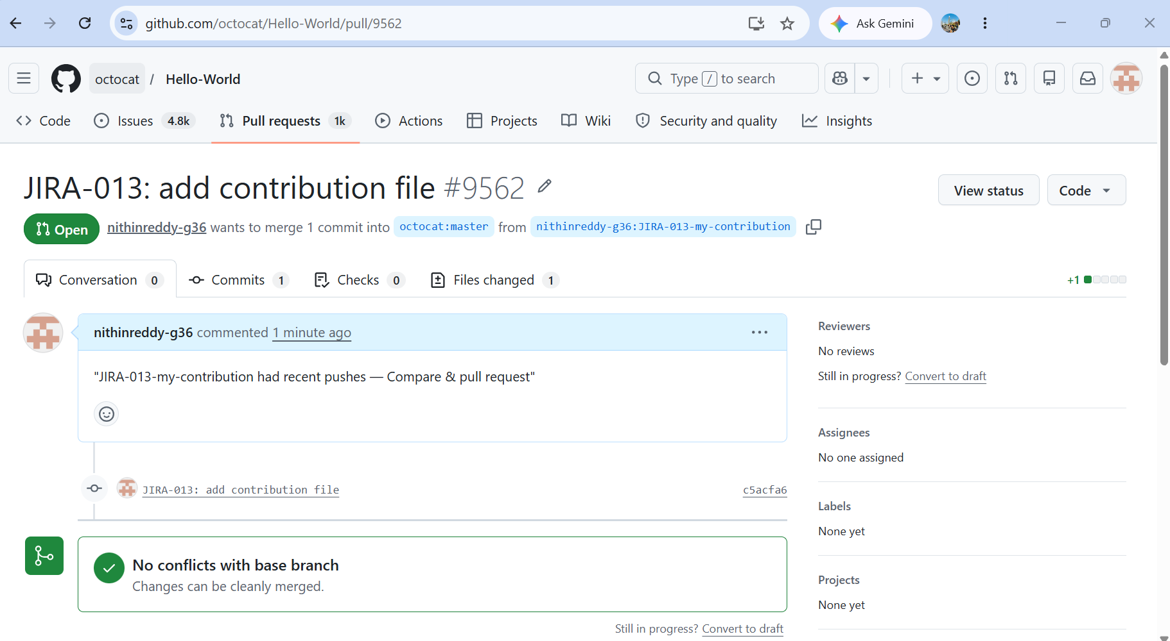
*Clicked Fork on a public GitHub repo to create my own copy. Cloned my fork locally. Created branch JIRA-013-my-contribution, added contribution.txt, committed and pushed to my fork. Added the original repo as upstream with git remote add upstream <url> and synced with git fetch upstream && git merge upstream/master. On GitHub clicked "Compare & pull request", filled the title and description, and submitted the PR.
Outcome: Pull request successfully submitted from fork to original repo. PR page showed the diff, branch name, and open status.
14. Recover Lost Commit
Objective: Commit something, lose it with git reset --hard, then recover it using git reflog.
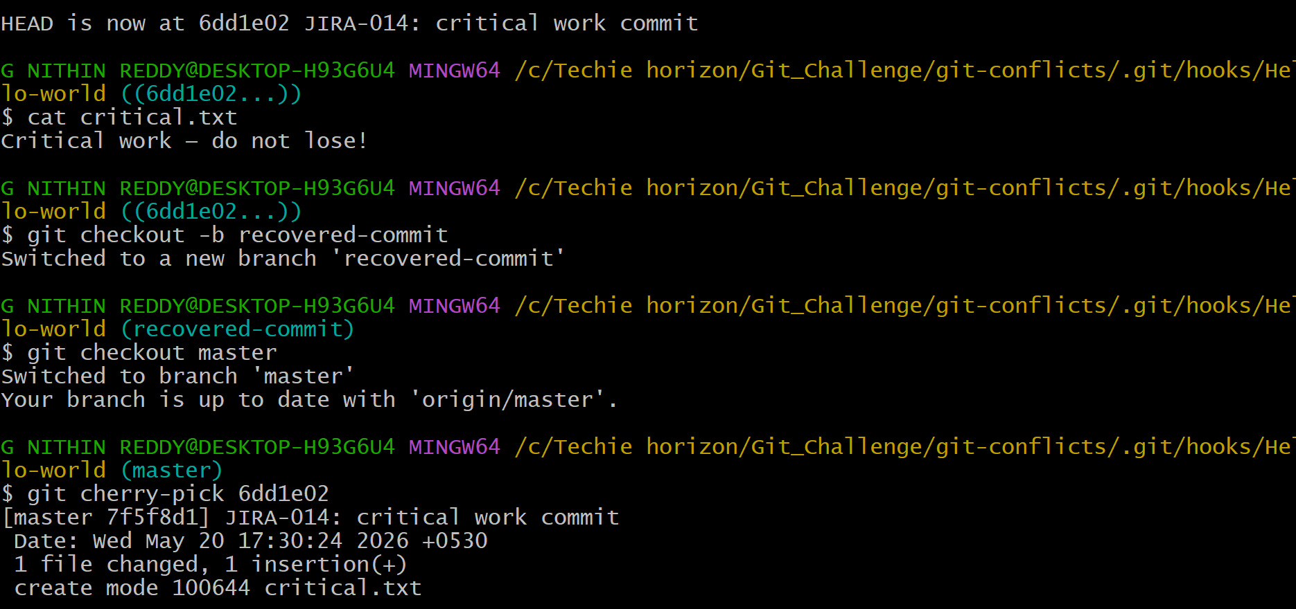
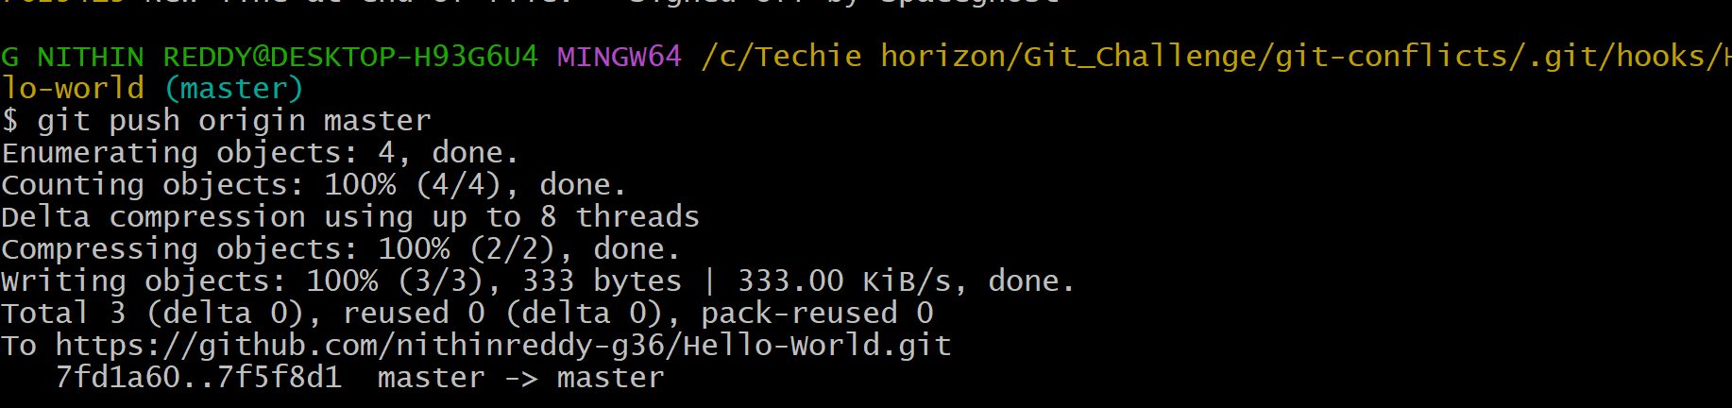
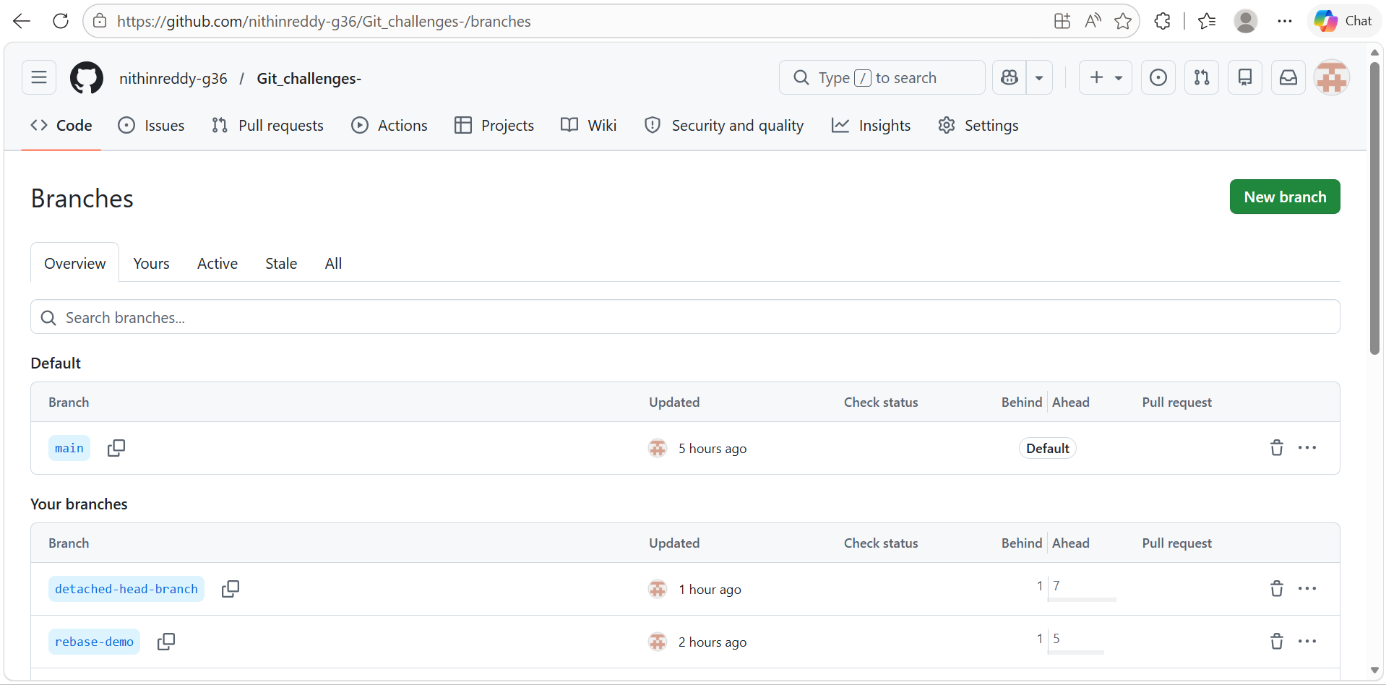
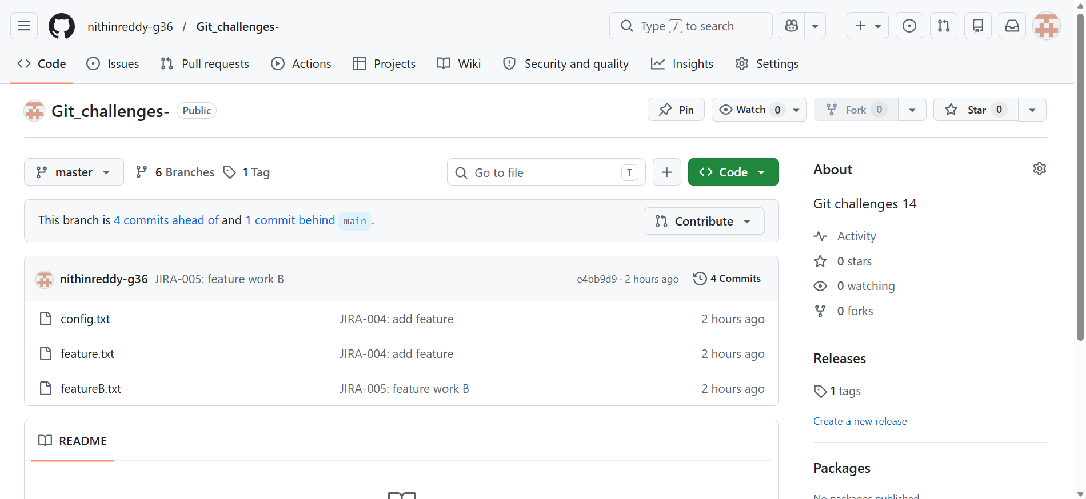
*Created critical.txt, committed it with "JIRA-014: critical work commit". Confirmed it in git log. Then ran git reset --hard HEAD~1 — commit was gone from log and critical.txt disappeared. Ran git reflog which listed all HEAD movements and showed the SHA of the lost commit. Checked out that SHA to verify the file was there. Used git cherry-pick <SHA> on master to bring the commit back. Pushed to GitHub.
Outcome: Lost commit was fully recovered using reflog and cherry-pick. Final git log confirmed the commit was restored — proving reset --hard is recoverable within ~30 days.

